
St. Louis Public Schools
Standards-Based Blended Learning Lesson Planner

Weekly Instructional Planner
Name | P. Sutton | Date | September 12 - 16 , 2022 | Grade & Subject | 1st Math
Lesson Topic | Topic 1: Solve Addition and Subtraction Problems to 10
Lesson Objectives | Content Objective(s) |  |  | Language Objective (ESOL)
 | Lesson 2: I can solve word problems about putting together.  Lesson 3: I can solve word problems by breaking apart the total number of objects.  Lesson 4: I can solve word problems that involve taking from a group.  Lesson 5:I can solve word problems that involve comparing  Lesson 6: I can solve problems by comparing |  |  | 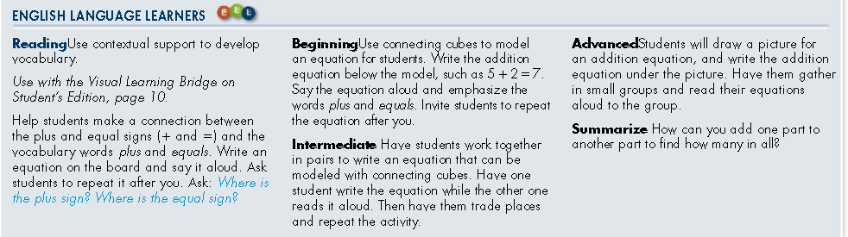
Focus Standard(s) | Standard |  |  | Prior Knowledge and/or Unfinished Learning Needs
 | 1.RA.A.1  Use addition and subtraction within 20 to solve problems.  Lessons 1-9 |  |  | 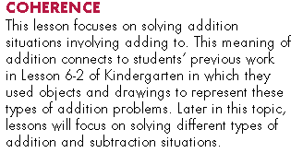
Essential Question & Vocabulary | Essential Question |  |  | Lesson Vocabulary
 | What are ways to think about addition and subtraction? |  |  | add, sum, plus, equals, equation, parts, whole, difference, subtract, minus
List of resources or strategies related to learner’s style & needs embedded throughout lesson | Cultural Context Differentiation |  |  | Integrated Technology
 |  |  |  | Savvas online resources: Daily Spiral Review, Quick Checks. Freckle.
 | Multi-Tiered Systems of Support (MTSS) Resources
Use real-life examples; multiple representation of problem/solution; error analysis; students use vocabulary to explain reasoning; number of problems
Differentiated practice on Freckle. MDIS pages: B4, B5, B9, B10, B11, B8. Reteaching and Enrichment pages for lessons 1-2, 1-3, 1-4, 1-5 and 1-6

 | MONDAY | TUESDAY | WEDNESDAY | THURSDAY | FRIDAY
 | Please be mindful to include specific learning activities, vocabulary strategies, instructional methods, differentiation, and check for understanding in each component of the lesson, as appropriate. Cultural Context Differentiation and Blended Learning should be integrated into all components of the lesson plan. Please see the Lesson Plan Guide Book for examples and more information.
Do Now  (Prior Knowledge or Unfinished Learning) | 1-2 Daily Review ( p.15A) | 1-3 Daily Review (p.21A) | 1-4 Daily Review (p.27A) | 1-5 Daily Review (p.33A) | 1-6Daily Review (p.39A
Engage  (Hook / Launch) | 1-2 Solve & Share (p. 15) | 1-3 Solve & Share (p21) | 1-4 Solve & Share (p.27) | 1-5 Solve & Share (p.33) | 1-6 Solve & Share (p.39)
Explore  (Activities) | 1-2 Look Back (on Solve & Share) (p. 15) | 1-3 Look Back (on Solve & Share)  (p. 21) | 1-4 Look Back (on Solve & Share) (p. 27 | 1-5 Look Back (on Solve & Share) (p. 33) | 1-6 Look Back (on Solve & Share) (p. 39)
Explain  (Demonstrate Learning) | 1-2 Visual Learning p.16  1-2 Do You Understand? (CFU) (p.16) | 1-3 Visual Learning (p.22)  1-3 Do You Understand? (CFU) (p. 22) | 1-4 Visual Learning (p.28)  1-4 Do You Understand? (CFU) (p. 28) | 1-5 Visual Learning (p.34)  1-5 Do You Understand? (CFU) (p. 34) | 1-6 Visual Learning (pg 40)  1-6 Do You Understand? (CFU) (p. 40)
Elaborate.  (Extend Thinking) | 1-2 Guided Practice (p. 16)  1-2 Problem Solving (p.18) | 1-3 Guided Practice (p. 22)  1-3 Problem Solving (p.24) | 1-4 Guided Practice (p.28)  1-4 Problem Solving (p.30 | 1-5 Guided Practice (p.34)  1-5 Problem Solving (p.36) | 1-6 Guided Practice (p.40)  1-6 Problem Solving (p.42)
Evaluate  (Exit Ticket) | 1-2 Independent Practice (p.17)  1-2 Quick Check on Savvas | 1-3 Independent Practice (p. 23)  1-3 Quick Check on Savvas | -4 Independent Practice (p.29)  1-4 Quick Check on Savvas | 1-5 Independent Practice (p.35)  1-5 Quick Check on Savvas | 1-6 Independent Practice (p.41)  1-6 Quick Check on Savvas
Closure  (Brief Review) | Review 1-2 Independent Practice & Quick (p.17) | Review 1-3 Independent Practice & Quick Check (p. 23) | Review 1-4 Independent Practice & Quick Check (p.29) | Review 1-5 Independent Practice & Quick Check (p. 35 | Review 1-6 Independent Practice & Quick Check (p. 41)
Extended Practice (Homework) | 1-2 Homework & Practice (pgs.19-20) | 1-3 Homework & Practice (pgs. 25 – 26) | 1-4 Homework & Practice (pgs. 31-32) | 1-5 Homework & Practice (pgs. 37 – 38) | 1-6 Homework & Practice (pgs 43 - 44)

Lesson Reflections
Prompts to help you get started on your lesson reflection...Daily
- Did scholars demonstrate, through their work and activities, that they are moving towards proficiency? If so, how do you know? What pieces of scholar evidence did you use to determine this?
- How have you / will you provide feedback to scholars?
- What questions or activities did you plan for to help scholars increase their depth of knowledge (DOK)?
- Were the scaffolds planned in last week’s instruction effective? What new supports might be added this week to help scholars demonstrate proficiency?
- How are formative assessments or exit tickets being used for the following day’s Do Now?
- How are you embedding and/or using vocabulary throughout your lesson?

